Dance Until You’re Dead
By Ariel Monticure
Oct. 4, 2022

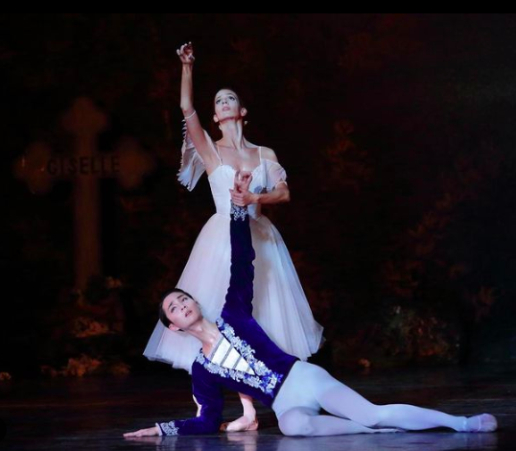
Perry Meadors & Shih-Yuan Huang in Ballet Frontier’s, “Giselle”. Photography by Colin Woolums.

Texans love the fall. It’s a welcome reprieve from the sweltering heat. Regardless if the temperature agrees with the season or not, chili will be made, pumpkin spice lattes ordered, and all things spooky will be consumed.
On October 2, Ballet Frontier performed their closing show of Giselle at the Will Rogers Auditorium. The haunting story of love, deceit, and revengeful spirits of heartbroken women was the perfect season opener.
Act I opens to a breathtaking set, a castle nestled in the mountain tops and a village in the foreground, basked in a golden wash. Immediately the subjects of a love triangle are introduced.
Lovestruck Duke Albrecht, danced by Shih-Yuan Huang, rushes in to stash his royal clothes and sword to disguise himself as a commoner. He has recently fallen in love with a peasant girl, Giselle, and hopes to win her affection despite being betrothed to another woman. While the duke masquerades himself, Hilarion, another suitor danced by Shannon Beacham, comes to court Giselle. In the midst of a heated pantomime exchange between the suitors, Giselle makes her choice known. She chooses Albrecht despite Hilarion’s distrust. Ecstatic dancing among the villagers ensues.
The depth and richness of the scenery and costuming is enhanced by the masterful technique and synchronous execution of the corps de ballet. While Giselle, danced by Perry Meadors, makes for a picturesque, willowy ingènue it’s the virtuosity of dancers Natalie Cisco, Shiori Ohama, Masanao Ito, and Danny Tran that draws the audience in. Their dynamic energy and strength portrayed in the Peasant Pas de Quatre livens the stage with every soaring jeté. Excitement of the love match transitions to a greeting party for visiting nobles. The dizzying festivities come to an abrupt, screeching stop as Albrecht’s true identity is discovered.
Dancers Huang and Meadors’ reaction to the news is a bit subdued for lovers whose world is falling apart, but to pantomime dramatically enough to fill the large space at the Will Rogers Auditorium is a feat. Within a few strained minutes, Giselle dies of a broken heart.
Act II opens as smoke rolls through the dimly lit stage to reveal an eerie forest and the tombstone of Giselle. Ghostly veiled women skim the stage en pointe and immediately the audience leans in to embrace the bewitchment. The Willis are led by their Queen Myrtha, danced by Audrey Williamson, to haunt men who’ve broken their hearts and force them to dance until death.
Lead Willis, danced by Caterina Brown and Michela Chiroli, kickoff the trance-like choreography as they hover in pique arabesques and assemblés.
Hilarion wanders into the forest to grieve Giselle’s death and runs into misfortune. Under Queen Myrtha’s orders, the Willis condemn Hilarion to death. Beacham expressively dances into a frenzy as Williamson beautifully and deliberately commands the stage. It is awe-inspiring and chilling to watch the corp de ballet of 24 ballerinas move as one as Williamson points directives.
Albrecht too visits Giselle’s grave and unwittingly walks into the same trap as Hilarion. The music dramatically crescendos as Huang jumps, beating his feet into inevitable death. Giselle intercedes, her love shields Albrecht from the curse, and a new morning dawns.
Similar to the occasional cooler weather in Texas, the breathtaking beauty of Ballet Frontier’s production came and went too soon. If you missed the season opener, run, don’t walk to Ballet Frontier’s upcoming performances. The 2022-23 season shows are The Nutcracker, Carmen & More!, and concludes with Sleeping Beauty. Tickets and information can be found at www.balletfrontier.org.

